“A Father’s Influence”
Father’s Day
June 21, 2020

- Prayer for Message and Messenger –
- Father’s Day Video – Sound Booth

This is a picture of my Mom and Dad; Leroy and Barbara Ballard

- Happy Father’s Day.
- We would like to recognize our Father’s this morning and pray over each of you.

I don’t do this very often, but I would like to be a little sentimental this morning. I just want to thank God for my wife, my daughter’s my son-in-law’s and my grandchildren. My family is a gift from God that I cherish more and more with each passing day.

Also, I thank God for giving me a believing Father and Mother who modeled what loving God looks like. (I would like to say that when I lost my Dad, my Mother became both Mother and Father (the best that she could) and I am grateful for that).
I am also grateful for:

- God’s providence, He placed me in my family for a reason,
- God’s provision, especially in my late teens when I was without a mentor, my faith was real and it led me to keep following God.
- God was so patient with me, and put me in storm after storm to teach me and to make me teachable.
- Last, I praise God for His grace, because without His grace and mercy, I wouldn’t be here with you this morning.

Picture of Jamie and Jennifer

Introduction:
- Research from the “National Fatherhood Initiative”
- Father’s factor in nearly all social ill’s facing America
- More than 1 in 4 live without a father
- A child w/o a father has a 4 X’s greater risk of living in poverty
- More likely to have behavior problems
- More likely to go to prison
- Girls are 7 x’s more likely to become pregnant as a teen
- More likely to abuse drugs and alcohol
- 2xs more likely to drop out of high school

No wonder God said to “train up a child in the way they should go” (Proverbs 22:6) and a father is an important part of that training.

Join me in Paul’s letter to the Ephesians 6:1:

Children, obey your parents in the Lord, for this is right. 2 “Honor your father and mother”—which is the first commandment with a promise— 3 “so that it may go well with you and that you may enjoy long life on the earth.”

4 Fathers, do not exasperate (irritate, frustrate, anger, provoke) your children; instead, bring them up in the training and instruction of the Lord. (NIV)

- After Paul challenges children to obey their parents, in verse 4; Paul turns his attention to the Fathers of the home.

- Dad’s/Fathers are like the Pastors of their home (whether they know it or not), God has ordained the role of the Father to lead their family in the training and instruction of the Lord.
- You should expect a Father to do at home; what a Pastor would do at church; love and protect their family, teach the gospel to their kids and do it as Paul admonished in Ephesians 5:15; “Speak the truth in love.”

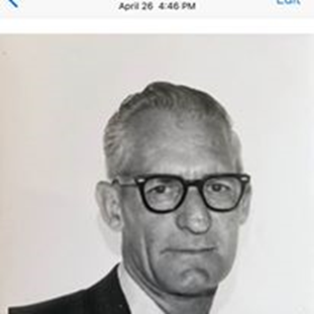This is a picture of my Dad, just before he became ill.

Allow me to share briefly about….

- The Father I knew: - Leroy Ballard

- The destiny of our family changed when a man by the name of F.M. Wood, came to Pastor the Free Will Baptist Church in Stratford, Oklahoma. Gilbert Pixley was holding a revival at the church and Pastor F.M. Wood went by my parents’ house each night to invite them to the revival. Dad would see the preacher coming and would go out the back door. Brother Wood persisted and finally my Dad told the stubborn Pastor; “I’m going to go to your revival meeting just to get you off my back.”
- Dad and Mom attended on a Saturday night and the Holy Spirit of God took the Word of God straight to my Dad’s heart. When the invitation was given, Dad went forward, Mom followed Dad, and the eternal destiny of our family was forever changed.
- There was a man in that church that Dad couldn’t tolerate, but Dad said when he got up from the altar, his whole attitude toward that man changed from that moment forward.
- Dad was a changed man. He made sure we were in church and heard the gospel; Mom was our Sunday school teacher part of the time and went over our Sunday school lesson with us each week.

- They elected Dad, adult Sunday school teacher, and eventually church treasurer and deacon. Dad said; “it was either sink or swim.”

- When I was a kid, I remember walking down the street in Ada, OK with my Dad one Saturday morning. A man came up to Dad and asked him for money. Dad told him he wouldn’t give him money but he would buy him a meal; then Dad began to share about how God changed his life. As a boy, that made a huge impact on me. Watching my Dad tell someone about Jesus.

- Another time an old army buddy came to Ada to visit my Dad. He was a pilot and wanted to fly us around the Ada area. Dad wasn’t real excited about a plane ride, but he knew I really wanted to, so we saw Ada from the sky. The old army buddy wanted to bring up the old army days and what all went on, (before Dad became a Christian) but Dad wasn’t having any of the, “talking about old times.” Instead he let him know God had changed his life. Once again, that had a huge impact on my life as a young teenager.

- How different would my life have been if F.M. Wood had not persisted, if my Dad hadn’t gone to the altar during that Saturday night revival, and if Mom hadn’t followed him.

- Where would I be today? What would I be doing? Mother’s do have a huge impact on the family, but as a Pastor, I have seen time and again the kids follow Dad while Mom prayed for her family to be saved.

• Due to our parents, all their children and grandchildren and great-grandchildren, and know, love and serve Jesus.
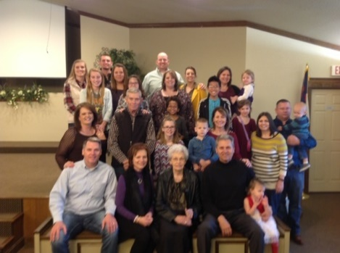 (A few of our family are missing in this photo)

My Dad made sure that I and my siblings heard about …..
- The Father I Didn’t know
(The Father my Dad pointed me to)

Matthew 5:48
Be perfect, therefore, as your heavenly Father is perfect.

• This is not talking about sinless perfection, but the challenge for you and I to hate sin as God hates sin and strive to live a life that honors and resembles our Heavenly Father.
- My Dad wasn’t perfect, but he introduced me to the Father who is perfect.
- I lost my Dad at 53 of cancer. I was 19 at the time.
- I’ve missed my Dad, and when you lose your Dad at a young age, it’s easy to idolize and make him out to be something he wasn’t.
- Dad wasn’t a perfect man, but he taught me that our perfect Father in heaven, made a way for us to become, “children of God” so we could have HIS NAME.

- My Dad was flawed, like us, but God, reached down from heaven, right to where Dad was, and His grace will reach down right to where you are this morning.

- Only the Father in heaven truly knows you, knows your sin, knows your need, and knows your potential in Christ.

- “If we confess our sins, God is faithful and just and will forgive us our sins, and cleanse us from all unrighteousness” – 1 John 1:9.

- Just like my Dad was forgiven of all his sins, he pointed me to the perfect Father in heaven who forgave me of all my sins.

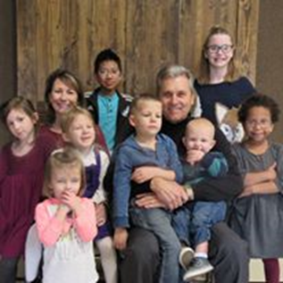

But this morning, I want us to focus on …….…
- The “Father” God called you/me to be

- I hope you have an earthly father in your life.
- I hope and pray he is a godly man who points you to the Heavenly Father who is perfect.
- Now, while your earthly father may instruct you how to be a man, your “calling” as a man, as a husband and father comes from your Heavenly Father.

Deuteronomy 6:5-7
5 Love the Lord your God with all your heart and with all your soul and with all your strength. 6 These commandments that I give you today are to be on your hearts. 7 Impress them on your children.

That word impress is described in the following verses. Listen closely;

Talk about them when you sit at home and when you walk along the road, when you lie down and when you get up. 8 Tie them as symbols on your hands and bind them on your foreheads. 9 Write them on the doorframes of your houses and on your gates.

In other words, commit to memory not only these commands but also all that God has done for you and in you.
Rehearse them to your children.

How can you do that?
- Read the Bible stories to your children at night before they go to bed.
- Tell them “how” you came to faith in Christ.

- I done many funerals in the last 4 decades. It never ceases to amaze me when I ask families about their loved ones spiritual journey that many times; “No one knows.”
- Tell your kids about your salvation.
- Pray with them.
- Pray a blessing over them and allow them to hear you pray that prayer of blessing.
- Let them see you pray with your wife.

I must say, I am so blessed to have a godly wife. She has loved me and our girls.

Our oldest daughter, Jamie Lynn, married our youth pastor, Daniel Sweet and they now Pastor and serve a church in Norman, OK.

My youngest daughter, Jennifer married a man who was a member of our church here at Woodcrest, Daniel Weaver. Both of my girls married men who love Jesus and raise their children to love Jesus, partly due to the prayers of my parents. Vickie and I are so blessed.

- I was not a perfect Dad by any means.
- There are a lot of things I wish I could do over.

- If that is where you are today, what I want to tell you is that “there is grace, healing and redemption in Jesus Christ.”

- Today, is a great day to decide to be a “father of influence for Jesus!”

I didn’t read the Bible to my children, but now, I do read it to my grandchildren.

But, when my girls were little, they would see me reading my Bible, and later, I would walk by the girl’s room where they would be on their bed, reading their Bible.

- I believe in prayer and I believe that, not only can Jesus redeem your eternity; he can redeem your family.

- Today is a new day.

- It doesn’t mean it will be easy.

- Men are generally willing to fight for many things.
- The question is; “Are you willing to fight on your knees for the eternal destiny of your family?”

